Title – Aim for maximum 12 words,
Arial 17 pt, bold, centered

Author, Author, Author, etc. (Arial, 11 pt, bold, centered)
Institution, Department (Arial, 11 pt, centered)
Or if different affiliation:
Author¹, Author², Author^{1,3}, etc. (Arial, 11 pt, bold, centered)
¹Author 1’s Institution, Department (Arial, 11 pt, centered)
²Author 2’s Institution, Department, osv

ABSTRACT
Aim for 150-250 words, in one paragraph. Do not use references in the summary. Tips on what the abstract can cover: Introduce the topic of the contribution and why it is important. Explain the problem and possibly which specific questions the contribution addresses. State how you have approached the question. Mention something about the most important results. Explain what we can learn (understand and/or use) from the work.

Nyckelord
Normally 3 to 6 keywords, with comma in between and a period at the end.

HEADING 1
Headings on the first level, use the Heading 1/Heading 1 style sheet. These settings are in the style sheet: Arial 11 pt, bold and capitals. The line spacing above the heading is 24 pt and 8 pt beneath.
Use the Normal style for the body text. These settings are in the format template: Arial, 11 pt. The text is aligned for straight right and left margins, single line spacing. Line spacing after the paragraph is 8 pt.
We recommend that the contributions are limited to a maximum of 10 pages. It is possible to write longer if the content warrants it, but please write effectively so that the contribution is pleasant to read.
Do not use page numbers as they will be added by the organizers when producing the conference proceedings. The footer should contain information about the conference as below.

Heading 2

For headings on the second level, use the Heading 2 style template. These settings are in the style template: Arial 11 pt, bold. The line spacing above the heading is 12 pt and 8 pt beneath.

Headings on level 3 are in italics

If you use headings on the third level, select the Heading 3 style template. These settings are in the style template: Arial 11 pt, italic style. The line spacing before the heading is 12 pt and after 8 pt.

Tables
It is fine to format tables as needed but consider readability and be consistent throughout the contribution. Table 1 shows an example of how tables can typically be formatted. The title comes before the table, with a blank line in between. Centre title and table. There must be a reference to the table in the text (Table 1).
Table 1. Sweden’s largest lakes.
 | Area, km² | Maximum depth
Vänern | 5330 | 106
Vättern | 1900 | 128
Mälaren | 1140 | 64
Hjälmaren | 480 | 20

Figures
Figures must be centered with reference (See Figure 1) and caption underneath. All figures must be referenced in the text (Figure X).
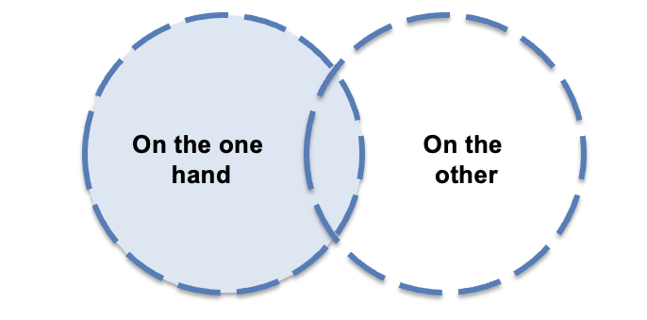
Figure 1. Perceived choices and decision anxiety (Edström & Johansson, 2022).

ABOUT references
We use a simplified APA format. The reference list below contains a link to a simple guide from the American Psychological Association (2022).

References in the text
In the running text, either write author and year in parentheses (Edström & Johansson, 2022), or refer like this to Edström and Johansson (2022).

Reference list
The reference list (see below) should be in alphabetical order. Use Arial 10 point. The line spacing is simple, but with 6 pt spacing between the references (to find in menu: Format / Paragraph… / Spacing After: 6).

Acknowledgements
Here we thank those who contributed in various ways. We also declare conditions that are significant for the work. The authors of this template would like to declare that we copied the one developed within the CDIO Initiative (Crawley et al., 2014), and modified it slightly.

Refterences
American Psychological Association. (2022). APA Style Common Reference Examples Guide. Retrieved at: https://apastyle.apa.org/instructional-aids/reference-examples.pdf
Crawley, E. F., Malmqvist, J., Östlund, S., Brodeur, D. R., & Edström, K. (2014). Rethinking engineering education: The CDIO Approach. Springer, Cham.
Edström, K., & Johansson, P. (2022). Det var vi som gjorde mallen [We made the template]. Eget förlag, Mälardalen.

ABOUT THE AUTHORS
This section starts on a new page. Introduce each author in a paragraph. Provide full contact details for the corresponding author. To be included in the proceedings, the authors must grant the Creative Commons version 4.0 license (see the link below for explanation).
Kristina Edström is a university lecturer in Engineering Education Development at KTH. She has a Master of Science in Engineering from Chalmers, and a PhD from KTH in Technology and Learning. She had the honor of organizing the first development conference for Sweden's engineering education programs back in 2008 at KTH, and has been to all conferences so far.
Pedher Johansson is a university lecturer and pedagogical developer at BTH. He has a master's degree in computer science from Umeå University. If all goes well, he is looking forward to organizing the 10th development conference in 2025 at BTH.

Corresponding author

Kristina Edström  KTH  Department of Learning in Engineering Sciences  100 44 Stockholm  kristina@kth.se | This work is licensed under a Creative Commons Attribution-NonCommercial-NoDerivatives 4.0 International License.

